Smart Mobile Phone Thermal Imager

Dongguan Xintai Instrument Co.,Ltd.
Add: Building F, No. 13-16, Hongye Industrial Zone, Tangxia community, Tangxia Town, Dongguan City
Postcode:523710 Tel:+86-769-82612006 Fax:+86-769-82612005
Website:www.hti-meter.com
https://hti-instrument.com www.xintest.en.alibaba.com

User Manual

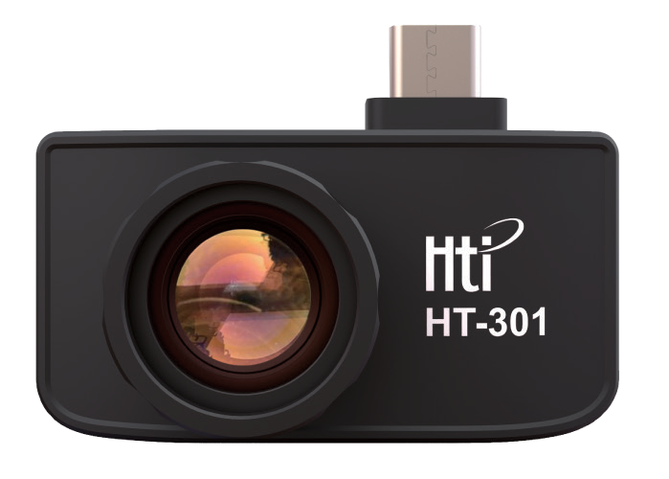

HT-301

Version No. V1.1
Revision date: September 7, 2019

Table of Content
- Considerations 1
- Product overview 2
  - Application scene 2
  - Main functions 2
- Software installation 3
- Product use 3
  - Equipment connection 3
  - Software operation 4
    - Gallery, camera and recording 4
    - Shutter 4
1. Considerations:
In order to protect you and other people from injury or your equipment from damage, please read all the following information before you use your equipment.
- Don’t let the product in direct sunlight or other sources of radiation with high intensity.
- Don’t touch or collide the detector window or the lens with hands or other articles.
- Don’t touch the equipment or USB interface with wet hands.
- Please don’t use thinner to wipe your equipment.
- Please note to prevent static.
- Don’t dismantle the equipment. Or there is any failure, please contact our company to repair it by professionals.

    - Temperature measurement analysis 5
    - Color palette 7
    - Temperature measurements setting 9
    - Other settings 10
5. Technical parameters 11

- Product Overview 3. Software Installation

  - Application Scene
To use HT-301 smart mobile phone thermal imager, it is necessary for your mobile phone to download and install Android mobile phone software for thermal imager and achieve infrared observation and infrared temperature measurement function through the software.
  - Main Functions: the following functions are achieved mainly.
- Open the application software of infrared thermal imager to conduct infrared observation.
- Conduct infrared temperature measurement and temperature analysis.
- Take photos and picture recording
- Action control and parameter setting of mobile phone thermal imager.

Scan the following two-dimensional code to download application software and install it.

4. Product Use
  - Equipment Connection: insert the infrared thermal imager into USB interface of the mobile phone and it will identify USB equipment automatically and pop out the prompt. Click “OK” and the software will start the mobile phone thermal imager and the mobile phone screen enters the infrared observation picture.

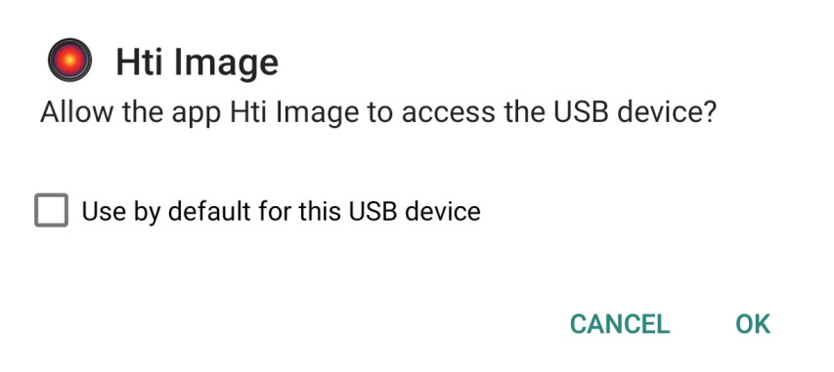

  - Software Operation

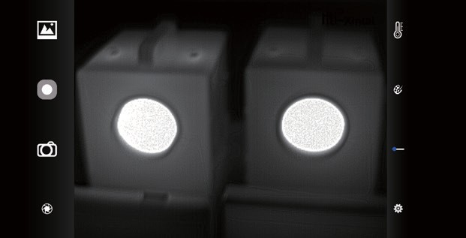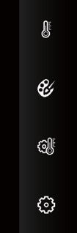Gallery Recording
Camera Shutter

Temperature
measuring analysis
Pallet
Temperature measuring device
Other setting

4.2.3 Temperature Measurement Analysis
Click button to pop out option of temperature measurement.

Point temperature measurement

Linear temperature measurement analysis

    - Gallery, Camera and Recording
- Gallery: Click to check the photos and videos stored in the mobile phone photo album.
- Camera: Save the current picture and the photo position is: Internal memory /DCIM/Htilmage.
- Recording: Click to begin the recording and click again to end the recording. The recording position is: Internal memory /DCIM/Htil- mage.
    - Shutter: click the shutter button to carry out heterogeneity correction.
Regional temperature measurement analysis

Temperature measurement option

- Point temperature measurement: Click the point temperature measurement button and the picture will display temperature informa- tion of three points, i.e., the core temperature point, highest tempera- ture point, lowest temperature point. At the moment, click the screen and the temperature information of self-defined points will be added.
- Linear temperature measurement analysis: Use fingers to drag and draw horizontal line on the screen and it will make analysis for the highest and lowest temperature on the horizontal line and mark relevant information.

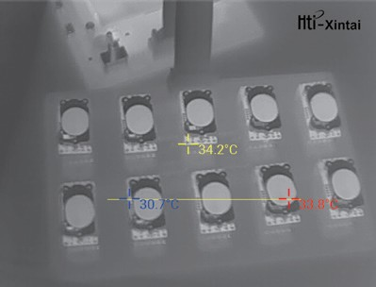
Linear temperature measurement analysis

- Regional temperature measurement analysis : Use fingers to drag and draw rectangle on the screen and it will make analysis for the highest and lowest temperature in the rectangular area and identify relevant information as the following diagram:

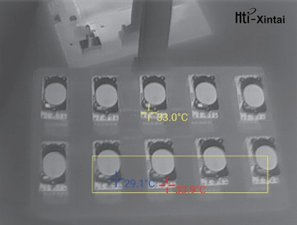
Regional temperature measurement analysis

Color Palette
Click “ ” button to pop out the pallet interface and you may switch among 6 types of pallets.

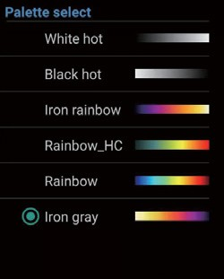
Palette menu

The display effect of 6 types of pallets is as follows:

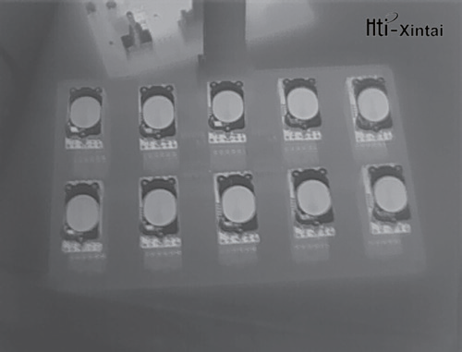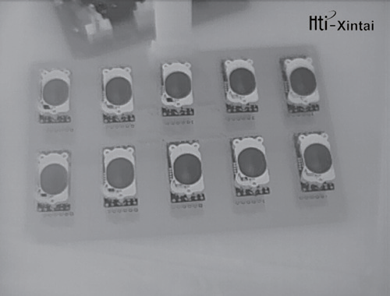
White hot Black hot

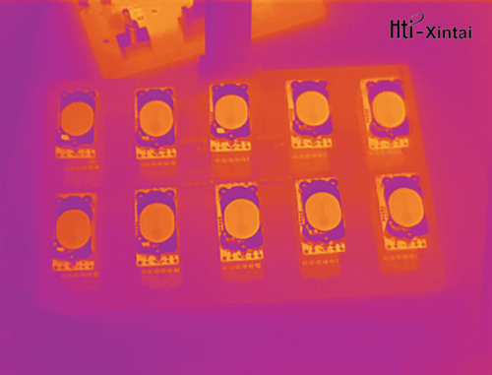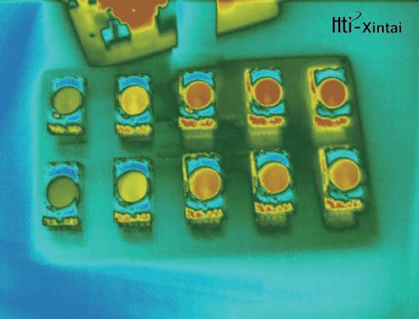Temperature Measurements Setting
Click “ ” button to pop out temperature measurement setting interface.

Iron rainbow Rainbow_HC

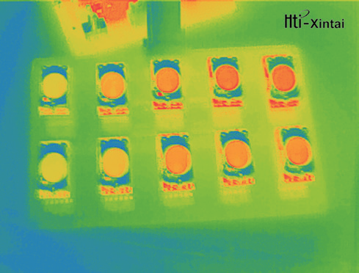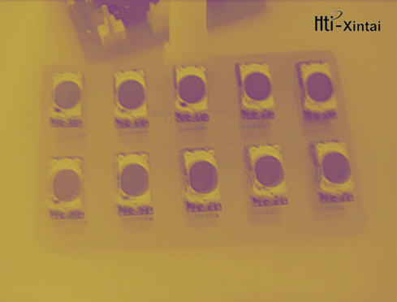
Rainbow Iron gray
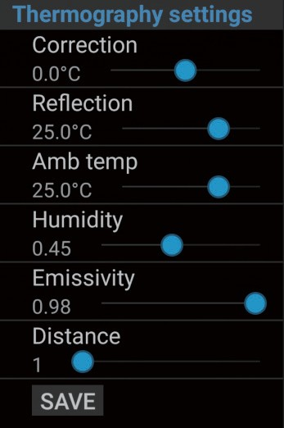

- Correction: Correct the error of temperature measurement;
- Reflection: The temperature of surrounding objects reflected on the target object.
- Amb temp: The environmental temperature of the target object;
- Humidity: The atmospheric temperature of the target object;
- Emissivity: Emissivity of the target object;
- Distance: The distance between the thermal infrared imager and target object.

Other Settings
Click the “ ” button to pop out the setting interface

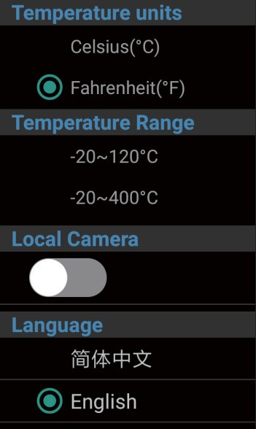
- Temperature units: Select Fahrenheit degree or degree centigrade;
- Temperature Range: The infrared thermal imager supports two temperature measurement scopes of -20℃-120℃ and -20℃-400℃
- Local Camera: you may select to open and close the mobile phone camera;
- Language: select Chinese or English

5.Technical Parameters
Infrared image resolution: | 384x288
Detector type: | Uncooled infrared focal plane detection
Temperature range: | -20 °C ~ 400 °C
Temperature measurement accuracy: | ±3°C or ±3%
Lens: | 13mm
Working Wavelength Range : | 8 – 14μm
Cell spacing: | 17μm
NETD: | ≤ 60 mK
Frame rate: | 25Hz
Temperature Measurement: | Maximum / Minimum / Center Value
Temperature Calibration : | Manual / Automatic
Temperature Output: | Real-time Output
Image Enhancement: | Multi-level Detail Enhancement
Image Calibration: | Shutter Calibration
Palette: | White hot, Black hot, Rainbow, and other
 | pseudo-color boards
Video Recording / Photo: | Support
Operating Temperature Range: | -10°C to 50 °C
Storage Temperature Range: | -20 °C to 60 °C
Interface Type: | Type-C Tnterface
Voltage Supply : | 3.8~5.5V DC
Size: | 49.5*36.1*29.3mm
Weight: | 45g

