O u tdoor Thermographic Telescope
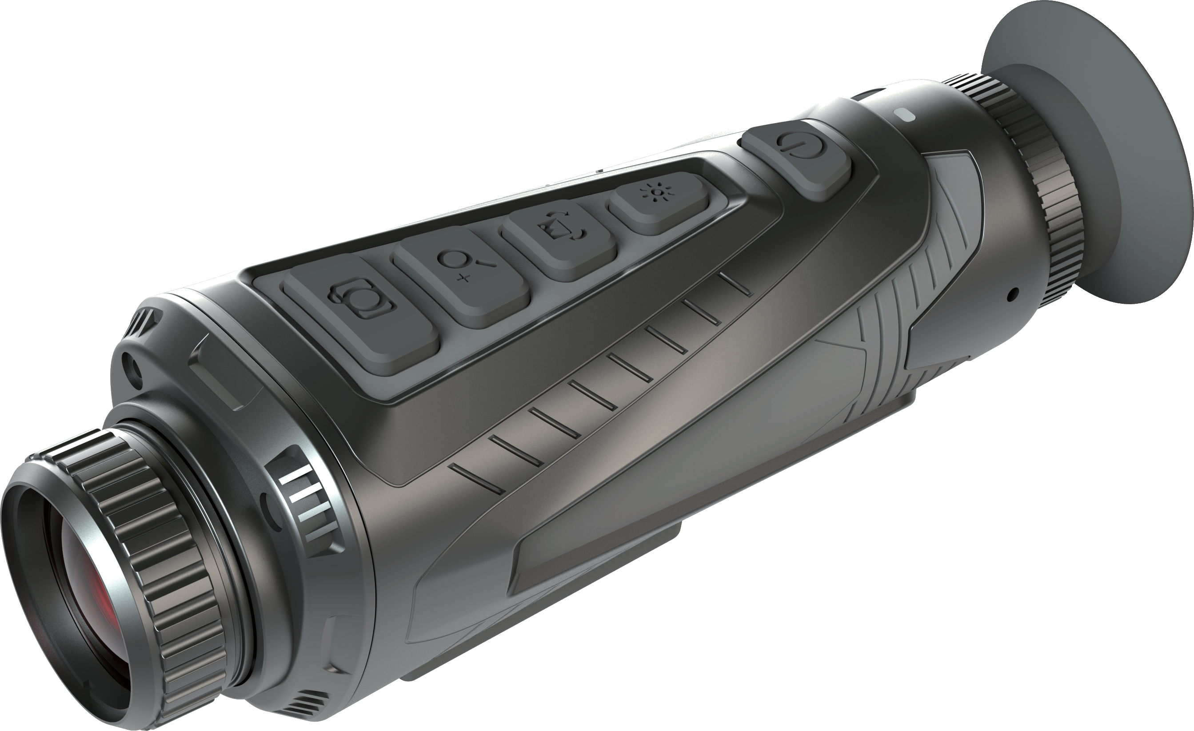
User manual

Dongguan Xintai Instrument Co.,Ltd.
Add: Building F, No. 13-16, Hongye Industrial Zone, Tangxia community, Tangxia Town, Dongguan City
Postcode:523710 Tel:+86-769-82612006 Fax:+86-769-82612005
Website:www.hti-meter.com
https://hti-instrument.com www.xintest.en.alibaba.com
User Manual Version 1.2. May 4, 2022

HT-A11

Table of Contents
Summary 1 Cautions and Safe Maintenance 1 Performance Indicators 3 Description of Menu Operation 6 Product Structures 11 Button Function Operation 13 Application of Color Palettes 14 WiFi App application 15 Product After-sale Service 17

Summary
The HT-A11 outdoor thermal image telescope takes advanced uncooled focal plane infrared detector and high-quality optical lenses as the core. Combined with convenient and fast operating system, it has a small appearance design, fully functional expansion spare parts, long service life, firmess and durability, so it is suitable for various environments, and creates a “clear imaging, simple operation and easy to carry” infrared thermal imaging tools for users.This product is used for field animal observation, search and rescue, police law enforcement investigation, night patrol, outdoor sports, personalsecurity, etc.
This product functions as photo taking and videos. You can browse the photos or videos taken through this unit or USB connected computer, so that several persons can observe at the same time creating possibilities for more applications.
Cautions and Safe Maintenance
In order that this product is properly used, please read the operation instructions carefully:
Never dismantle or refit this product without authorization. Do not use this product in the flammable, explosive, humid or corrosive environment.
This product contains precision electronic and sensitive optical devices. Please do not make it collide or fall so as not to cause any damage.
The housing of this product must be cleaned with wet cloth or weak soap. Do not use abrasives, isopropanol or solvents for cleaning. Optical lens cleaners must be used for lenses and screens.
There will be minor clacks every several seconds while this product works. This is the sound uttered by lenses, which is a normal case.
Warning: Do not look directly at the sun with lenses, for this will damage the optical lenses.

Performance Indicators
System function | Electron doubling | ×2/×4
 | Color palette | White hot, black hot, rainbow, hot metal, yellow saturation and bird watching mode
 | Brightness adjustment |  | 10 levels
 | Contrast ratio adjustment |  | 10 levels
 | Image detail mode |  | 2 types and 5 levels
 | Photo taking |  | Supported
 | Camera shooting |  | Supported
 | Picture in pictures |  | Supported
 | WIFI |  | Supported
 | Hotspot tracking |  | Supported
 | Language |  | Chinese and English
 | Standby |  | Supported
 | Laser lamp |  | Supported
 | Lighting lamp |  | Supported
Detection distance | Infrared  objective lens | 25mm objective  lens | 35mm objective lens
 | Character | ≤1667m | ≤2333m
 | Boar | ≤1471m | ≤2059m
 | Vehicles | ≤2501m | ≤3500m
Identification distance | Character | ≤416m | ≤583m
 | Boar | ≤367m | ≤515m
 | Vehicles | ≤626m | ≤875m
Storage | Built-in memory | Standard configuration 16G  (supporting 16G/32G/64G/128G)
 | Image format | JPG
 | Video format | MP4

Infrared detector | Detector type | Amorphous silicon uncooled infrared focal plane
 | Resolution | 384×288
 | Pixel size | 17μm×17μm
 | Operating band | 8~14μm
 | Performance  （NEDT) | ＜40mk (50Hz, F/1, 300K)TFPA 25°C(± 5°C)
 | Performance  (Scene dynamic) | ＞50°C (50Hz, F/1, 300K)TFPA 25°C(± 5°C)
 | Frame rate | 60Hz
Infrared objective lens | Focus mode | Manual focusing
 | F coefficient | 1.0
 | Effective imaging surface | Φ8.2mm | Φ8.2mm
 | Focal length | 25mm | 35mm
 | Field angle | 14.9°×11.2° | 10.7°×8.0°
 | Focusing range | > 1.0m | > 1.0m
Eyepiece | Focal distance |  | 22.0mm
 | Eye relief |  | 30.8mm
 | Exit-pupil diameter |  | 6mm
 | Visual adjustment |  | ±4SD
 | Apparent magnification |  | 12.5X
Display | Display screen type |  | LCOS
 | Resolution |  | 1280×960
 | Display screen size |  | 0.4 inch

Description of Menu Operation
Interface | CVBS output | Supported, SMA base interface
 | USB interface | TYPE-C exporting pictures, videos and battery charging function
Power supply | Non removable rechargeable  lithium battery |  |  | 18650/3500mAh
 | Overall power supply |  |  | ≤2W
 | Endurance time |  |  | ≤5.5 hours
Operating/ Storage environment | Operating temperature |  |  | -20℃ ~ +50℃
 | Storage temperature |  |  | -30℃ ~ +60℃
 | Impact resistance |  |  | ≤30g
 | Protection level |  |  | ≤IP65
Overall  dimension/  Weight | Overall dimension |  | 187*67*67mm | 198*67*67mm
 | Weight |  | 503g±5g | 513g±5g

1，Main menu: Long press the menu button for 2 seconds to enter the main menu, press the Up button or Down button to select, press the menu button for confirmation, press theshooting button to quit the main menu, or if there is nooperation within 30 seconds, quit the main menu.
2，Main menu interface: color palette, hotspot tracking, magnification, brightness, contrast, detail mode, WiFi, picture in picture, pictures and system.
3，Color palette: 6 color palettes, white heat, black heat, rainbow, hot metal, yellow saturation and bird watching mode, with the default value as white heat. Press the Up button or Down button for selection, and press the menu button for confirmation, and return to the main menu.
4，Hot spot tracing: on, off, default value as off. Press the Up button or Down button to select on or off, and press the menu button for confirmation and return to the main menu,

5，Brightness: 10 levels (0-9), with the default value as 4 levels. Press the Up button or Down button to select , press the menu button for confirmation and return to the main menu, and the corresponding brightness icon displays.
6，Contrast: 10 levels (0-9), with the default value as 6 levels. Press the Up button or Down button to select , press the menu button for confirmation and return to the main menu, and the corresponding contrast icon displays.
7，Detail mode: (Edge and detail) with the default value as the edge mode, 3 levels, image detail mode, only one mode can be displayed, and two modes cannot be displayed simultaneously.
- Edge: Press the Up button or Down button to select edges, press the menu button to conform entering the second layer of menu (0, 1, 2, 3, 4). Press Up button or Down button for selection and press the Menu button for confirmation and return to the previous menu, and press Shooting button to return to the main menu.
- Detail: Press the Up button or Down button to select details, press the menu button to conform entering the second layer of menu (0, 1, 2, 3, 4). Press the Up button or Down button for selection, and press the Menu button for
confirmation and return to the previous menu, and press the shooting button to return to the main menu.
8，WIFI: on, off, default value as off. Press the Up button or Down button to select on or off, press the menu button for confirmation and return to the main menu, and correspond- ing WIFI icon displays.
9，Picture in picture: on, off, default value as off. Press the Up button or Down button to select on or off, and press the menu button for confirmation and return to the main menu.
10，Picture: (picture and video) default value as picture
- Press the Up button or Down button to select pictures, press the menu button to confirm entering the picture list, press the Up button or Down button for selection, shortly press the shooting button to return to the previous menu, long press the shooting button for 2 seconds to delete the corresponding picture. Press the menu button to enter the corresponding picture browsing, and press the menu button again to return to the picture list.
- Press the Up button or Down button to select video, press the menu button to confirm entering the video list, press the Up button or Down button for selection, shortly press the shooting button to return to the previous menu, long

press the shooting button for 2 seconds to delete the corresponding video. Press the menu button to enter the corresponding video browsing, and press the menu button again to return to the video list.
11. System: Menu (shutter correction, laser, LED, video output, status icon, language, date, reset and about)
- Press the Up button or Down button for selection, press the menu button for confirmation, and press the shooting button to return to the previous menu.
- Shutter correction: (Automatic shutter, manual shutter, semi-automatic shutter) default value as semi-automatic shutter and press the Up button or Down button for selec- tion, and press the Menu button for confirmation and return to the previous menu.
- Laser: (on, off) default value as off
Press the Up button or Down button for selection, and press the Menu button for confirmation and return to the previous menu.
- LED: (on, off) default value as off
Press the Up button or Down button for selection, and press the Menu button for confirmation and return to the previous menu.
- Video output: (on, off) default value as off
Press the Up button or Down button for selection, and press the Menu button for confirmation and return to the previous menu.
- Status icon: (on, off) default value as on
Press the Up button or Down button for selection, and press the Menu button for confirmation and return to the previous menu.
- Language: (Chinese, English) default value as Chinese Press the Up button or Down button for selection, and press the Menu button for confirmation and return to the previous menu.
- Date: (year, month, date, hour, minute, second) default
value as no change in parameters
Press the Up button or Down button to select year, month, date, hour, minute and second, press the menu button for confirmation, press the shooting button to return to the previous menu, press the Up button or Down button to select corresponding parameters, and press the Menu button for confirmation and return to the previous menu. i.Reset (on, off) default value as off
Press the Up button or Down button for selection, and all parameters restore to the default value. Press the Menu button for confirmation and return to the previous menu.

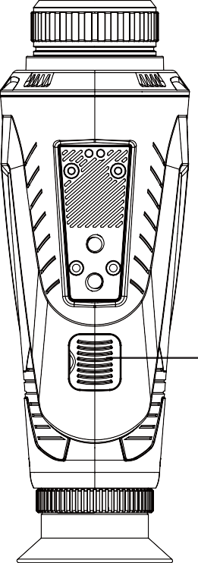
Product Stuctures

Brightness control

Zoom in button/ shutter correction/ Up button

Visual adjustment knob

Eyepiece eye mask
Infrared thermal image sensor

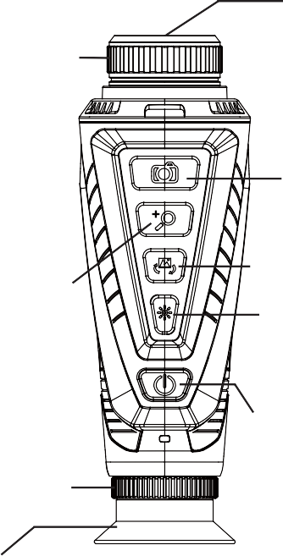
Photo button/ Video button / Escape button
Color palette button/
Menu button
Brightness button/ Hot spot tracking/ Down button
Power button/
Standby button

(Before use, open the safety cover first) CVBS video output interface, Type-C interface

Button Function Operation
- Power supply (standby): Long press the power supply key for 3 seconds to switch the machine on and off, short press the power key to enter standby, and then short press the power key to exit standby, power on or standby, and the power indicator is on
- Shooting (Viedo recording): Shortly press the shooting button for photographing function, the photographing icon flashes once, there is the photographing status. If the magnification is X2, then press X2 for picture storage. If the magnification is X4, press X4 for picture storage, long press the shooting button for 2 seconds for video recording, the video icon flashes, and long press the shooting button for 2 seconds for video recording to end and exit. The video icon is off, and the recording status is not affected by the magnification.
- Zoom in (Up button): Shortly press the zoom in button, X1, X2 and X4 switch, and the corresponding zoom in icon will be displayed. In the manual or semi-automatic state, long press the zoom in button for 2 seconds to manually correct the shutter once.
- Color palette (menu): Color palette (menu): Shortly
press the palette button, white heat, black heat, rainbow, hot metal, yellow saturation, bird watching mode and color palette switch, and long press the color palette button for 2 seconds to enter the menu mode.
- Brightness (Down button): Shortly press the brightness button, and brightness 10 levels are switched, and corre- sponding brightness icon is displayed. Long press the button for 2 seconds to turn on or off the hotspot tracking function.

Application of Color Palettes
The palette menu can change the pseudo color of infrared thermal image, and provide 6 color palettes: rainbow, hot metal, white heat, black heat, yellow saturation and bird watching mode.
The selection of suitable color palette can display details of the target. For rainbow, hot metal color palette focuses on the display of colors, so it is very suitable to high heat contrast used to improve the color contrast between high temperature and low temperature. Then the color palette of white heat provides uniform linear colors.

Image effect shot by six color palettes:

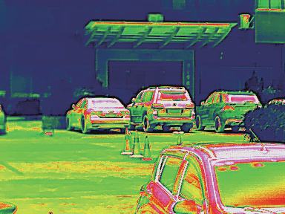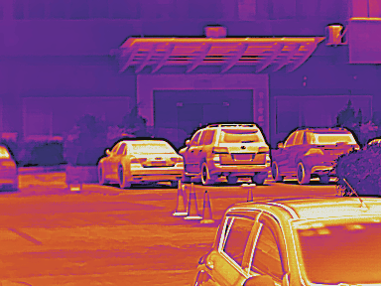
Rainbow Hot metal

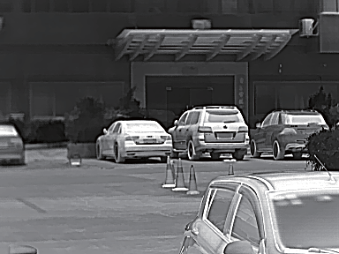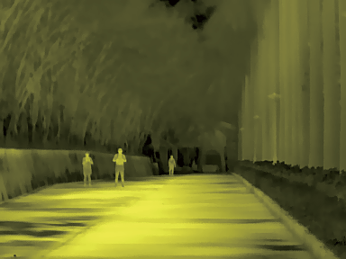
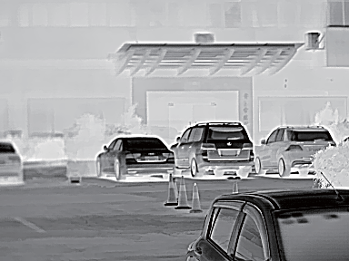
Black heat

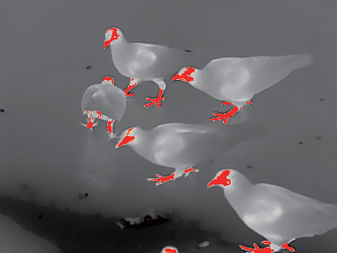
- In the mobile phone picture, click “ ” to return to APP picture; click “ ” to take photos and save it in the photo files. Click “” to start the video recording and click “ ”again to stop video recording. The video is saved in the video file.
- Click “ ”to enter “ ” and “ ”. Click “ ” to enter the photo file list. Click the corresponding picture to preview the picture or delete it. At the picture preview state, you may share the picture to Wechat, QQ, Email, Tiktok, etc. The share method is supported by corresponding functions of your mobile phone.
- Click “ ” to enter “ ” list. Click the corresponding video to play or delete it. At the state of video play, you may share the video to Wechat, QQ, Email, Tiktok, etc. The share method is supported by

White heat
Yellow saturation Bird watching mode
corresponding function of your mobile phone.

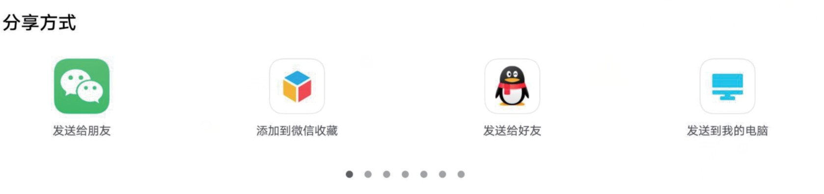WiFi App application
Share methods
Send to friends
Add to WeChat collection
Send to good friends
Send to my computer
- Search and install “thermal Video 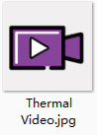 ” through the application store on the mobile phone.
- 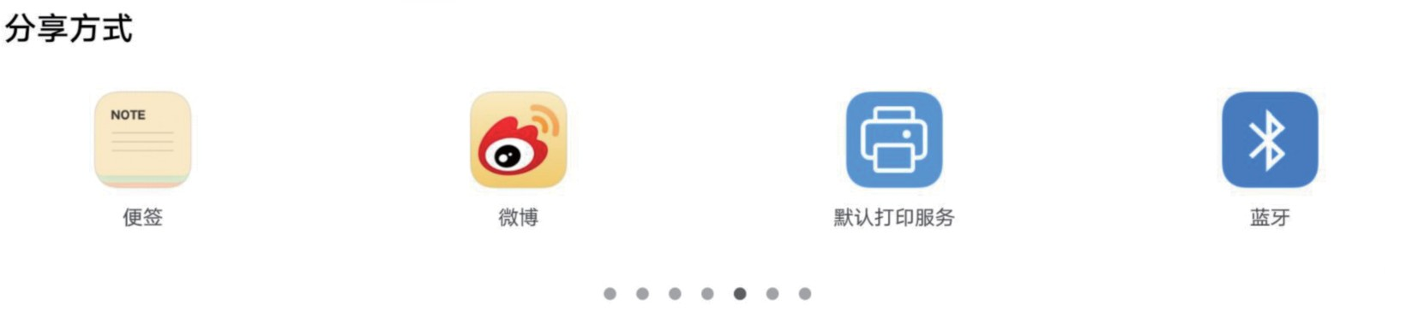Open the WIFI function in the menu setting for A11 machine. 3.Find the WIFI name “PFV01_WIFI” on the mobile phone and connect WIFI.
Share methods
Note
Microblog
Default print service
Bluetooth
- Open the App and enter APP picture and click key on the picture to enter APP mode. At the moment, the picture of the mobile phone should display with the machine picture synchronously.

Product After-Sale Service
Dear our customer,
Thank you for having purchased our products. The warranty period of this product is from the date of sale.
During the warranty period, the product shall be installed and used in accordance with the operation instructions under normal environ- ment and conditions. If the defective product is caused by raw materi- als and processing process, you will be entitled to free maintenance service with the warranty certificate. You are kindly requested to keep the warranty certificate properly, for there will be no reissue of it in the case of loss thereof.
To avoid problems in the process of application, we recommend that you be familiar with the product manual before using the product.
- The product is beyond the warranty period.

Cautions:
- In case of any product failure, the product will be inspected and repaired or replaced with new or good products as the case may be;
- For any products beyond the warranty period, it will be decided whether to repair or replace parts and components after product inspection, and charge related fees for various maintenance and replacement services.

Under any of the following circumstances, the product will not be covered by the warranty:
- The original of valid warranty certificate fails to be presented;
- Damage caused by product installation not meeting product requirements and relevant specifications;
- The user's improper use of the product, improper storage, unauthorized disassembly, unauthorized maintenance and other reasons.
- Damaged caused by natural disasters (such as earthquake, flood or lightning strike), or external disasters (such as fire or house collapse).

